Parameters

# Sprint 1

Categorization of app into 3:

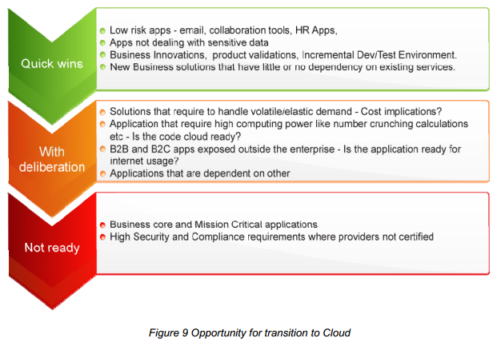

1. **Type of Application.** This will provide:
   1. Security – clouds that offer security protocols, etc.
   2. Domain / sector of the application, suitable for which deployment structure (public , private, hybrid)
      1. Credit card information can’t be on public etc.
      2. Regulatory issues – Banking, government, etc
   3. Mission-critical
   4. Is tightly coupled architecture required? (Not suitable for cloud). Preferable - service oriented architecture
   5. Is manual installation of application required?
2. **How many users will access the application at a time? (Capacity and Frequency of Use)**
3. **Life-Cycle status**
4. **Frequency of change** (continuous development or integration)
5. **External dependencies**
   1. Open source or licensed – restrictions applicable for scalability and extra costs
   2. OS, DBs, LDAP /etc. If accessing multiple databases, latency will occur – cloud not recommended
6. **Resources being used by the application (Tech perspective)**
   1. Sharing resources or not
   2. Load balancing?
   3. Providing dedicated resources?
   4. Memory for each instance
   5. Hardware resources / scalability – CPU usage
   6. Network architecture – fixed IP hosting and routing for dynamic mgmt
   7. Session state-> then paas not iaas
   8. Parallel processing/scalability? y/n
   9. Does the application use local file system? If yes, then that can be a problem
7. **Cost / investible / savings – request handling**
   1. Capacity
   2. Mobility – geographical availability

Customer satisfaction – in our DB – Module 2 input from web

# Sprint 2

Framework

Logs(which clouds offer soln)